Sora/ PWC Public Library
https://soraapp.com/library/pwcsva

3 Ways to Log In:

1.
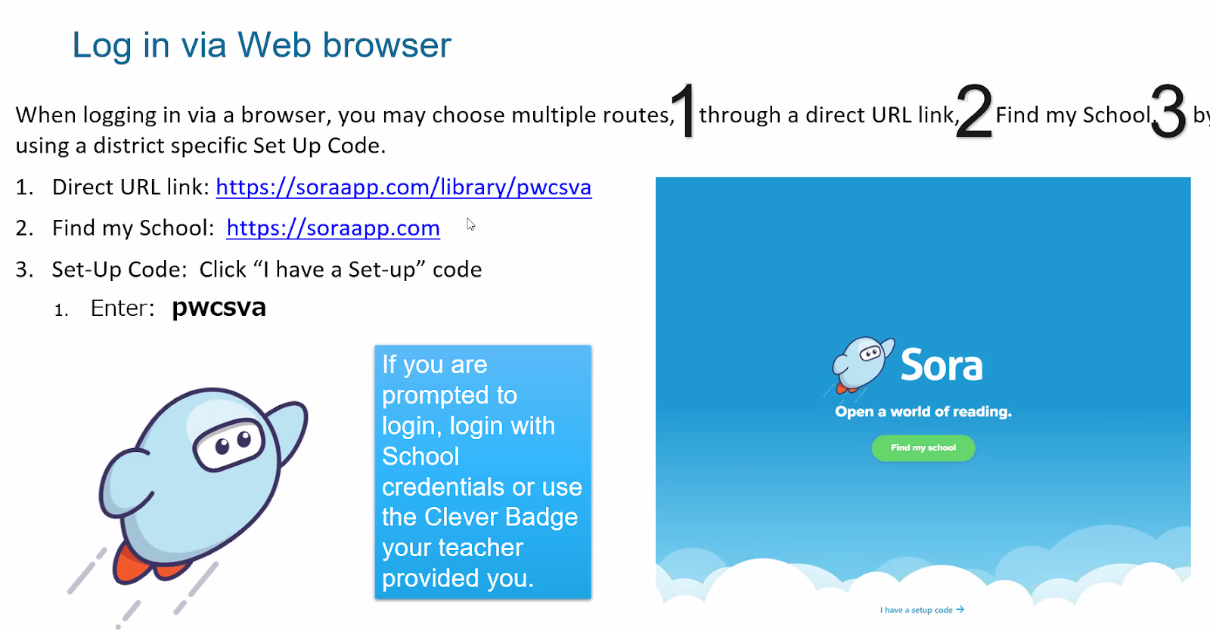

2.
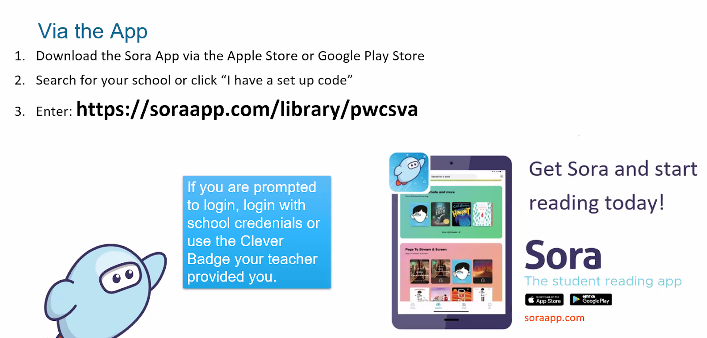

3.
